[PSoC 4 Pioneer Kit Community Project#20 - Starter Designs](http://www.element14.com/community/message/78074" \l "78074/l/psoc-4-pioneer-kit-community-project20--starter-designs)

 Did you know that PSoC Creator ships with many example projects to get you quickly up and running with PSoC 4?

One category of these examples that ship with the tool are called "Starter Designs" -- intended to be examples of common design configurations used in typical embedded systems.

 I will show you how to access these Starter Designs today -

 1. Launch PSoC Creator and start a New Project from the File menu

[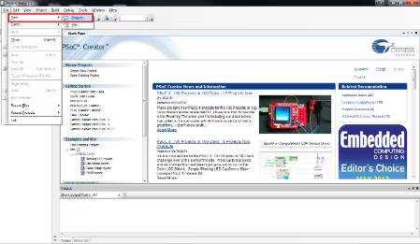](http://www.element14.com/community/servlet/JiveServlet/showImage/2-78074-151098/project20_01.png)

 2.From the New Project window, scroll down to see the Starter Designs for the PSoC 42xx family. Here, you can select from the 5 included starter designs. You can also provide you own project name and path, and then press OK to create a new copy of this project on your computer.

[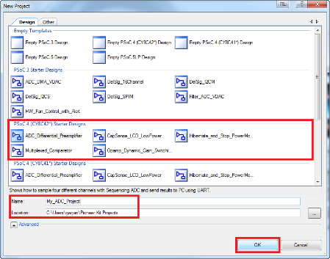](http://www.element14.com/community/servlet/JiveServlet/showImage/2-78074-151099/project20_03.png)

 3. In this example, I picked the first starter design "ADC_Differential_Preamplifier" and named it "My_ADC_Project". Once this new project is created, you will observe the already completed project schematic (topdesign.cysch), the project firmware (main.c) and also a document decribing this project in details (ADC_DiffPreamplifier.pdf).

[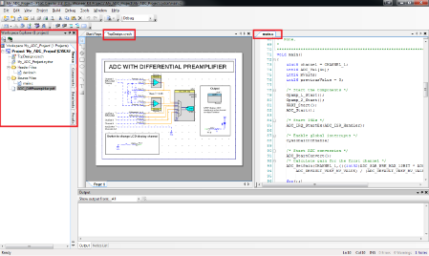](http://www.element14.com/community/servlet/JiveServlet/showImage/2-78074-151103/project20_04.png)

 4. To learn more about this particular project, see the included PDF document.

[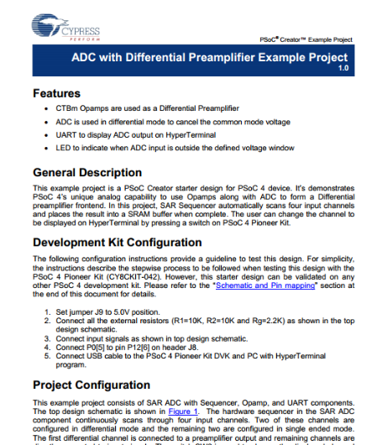](http://www.element14.com/community/servlet/JiveServlet/showImage/2-78074-151104/project20_05.png)

 5. Finally, assign the GPIO for your project based on what target hardware you are going to run it on (e.g. the PSoC Pioneer Kit). Once completed, you can then Build and Program this project on your PSoC 4 Pioneer Kit.

[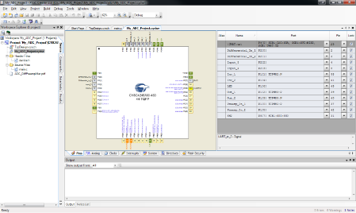](http://www.element14.com/community/servlet/JiveServlet/showImage/2-78074-151105/project20_06.png)

 Here's a list of the 5 Starter Designs included with the current version of PSoC Creator 2.2 SP1.

[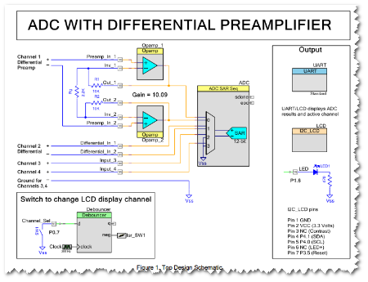](http://www.element14.com/community/servlet/JiveServlet/showImage/2-78074-151106/starter1.png)[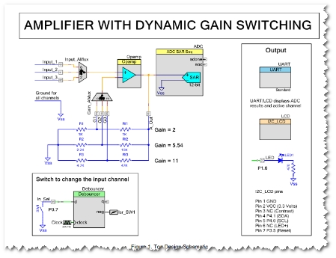](http://www.element14.com/community/servlet/JiveServlet/showImage/2-78074-151107/starter2.png)[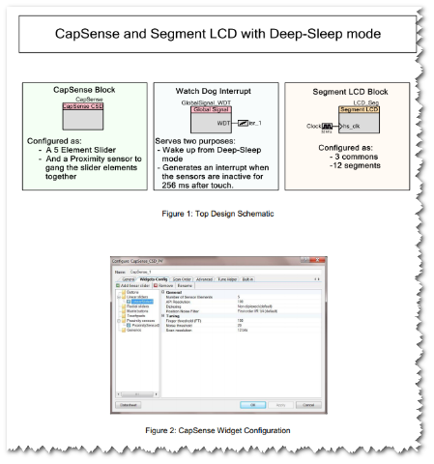](http://www.element14.com/community/servlet/JiveServlet/showImage/2-78074-151108/starter3.png)[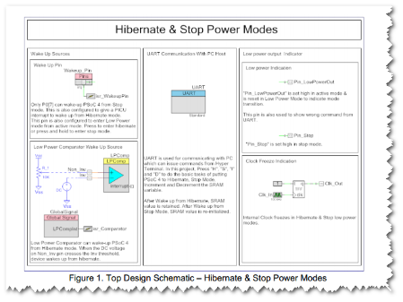](http://www.element14.com/community/servlet/JiveServlet/showImage/2-78074-151109/starter4.png)[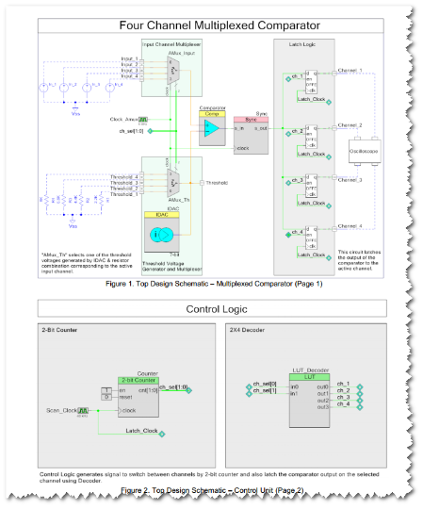](http://www.element14.com/community/servlet/JiveServlet/showImage/2-78074-151110/starter5.png)

<http://www.element14.com/community/message/78074>